**Assignment 2**

1. Please do refer to the pbix file attached.
2. a. Line Chart

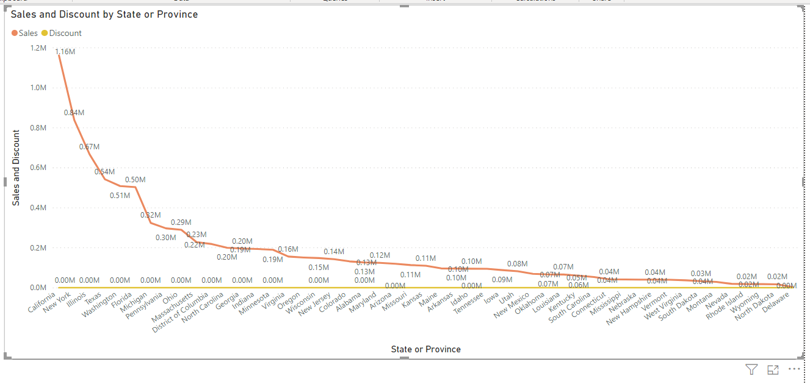

b. Clustered Column Chart

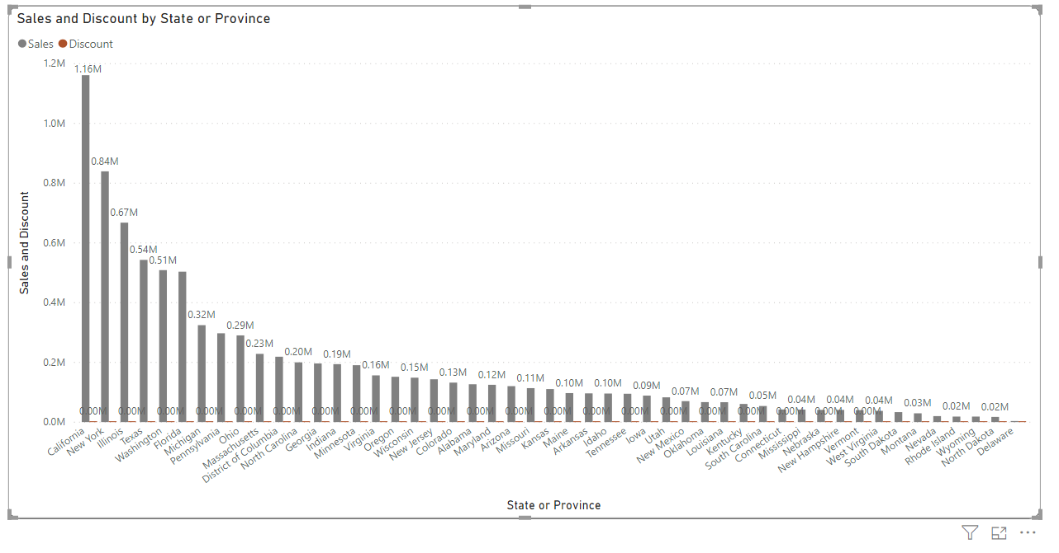

**Rhode Island** state has highest sales in terms of **Technology**.

1. Donut Chart

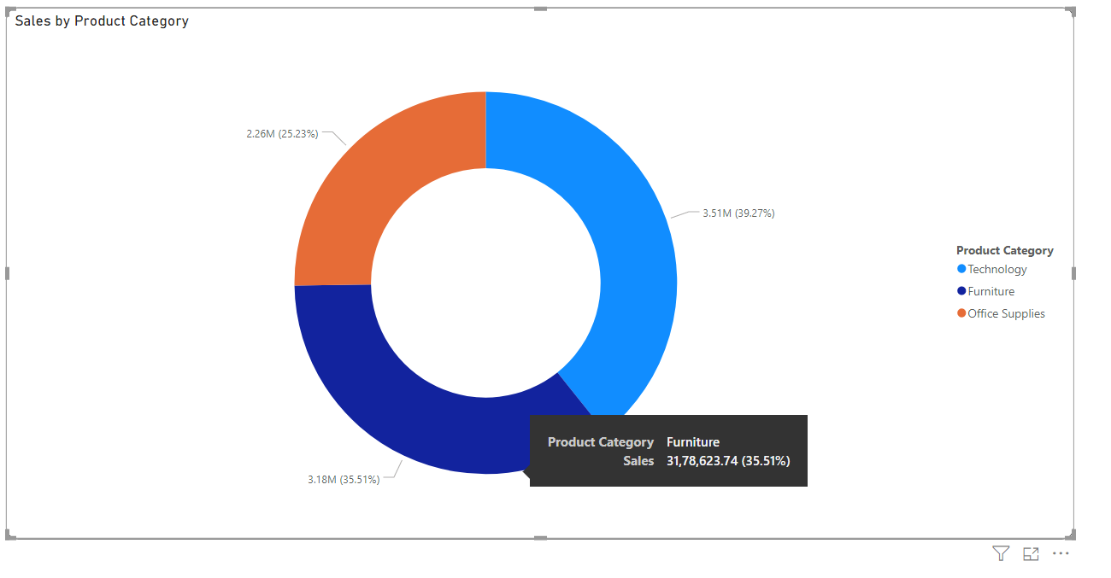

1. Slicer

